# The Early Childhood Inclusion Center of Excellence logo of just “us” in blue with the sun above it.

# Little SPARK: Simple Play Adaptations to Reference for Kids

## Time Tracker Mini

**Materials:** Simple timer with three colored lights and an optional alarm with visual and auditory cues for timed activities.

3 AAA batteries

**Who Might Benefit?**

Those who benefit and/or are motivated by visual schedules and/or visual passage of time to transition smoothly between activities, stay on task, and complete tasks.

**Image:**

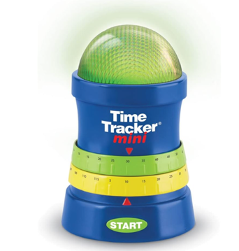

**Why Use?**Provides an opportunity to understand the passage of time, prepare for transitions, and stay focused on tasks for a set amount of time.

|  |  |
| --- | --- |
| **Instructions for Use:** | **Adaptation Ideas:** |
| **Environmental Considerations**   * Portable and accessible in all environments. * Alarm feature is optional for anyone who is noise-sensitive or in a quiet area.   **Positioning**   * Place on table or floor to use during tasks completed in a variety of positions where the child can see and hear the timer.   **Alternate Positioning**   * Slanted: Place on slanted surface such as a 3-4 inch 3 ring binder to help with viewing and reach.   **Basic Play/Use**   * Set the volume, the total countdown time, pre-alarm time, and then press the start button to initiate the timer. * Twist the green timer dial to choose the desired in 5-minute increments and twist yellow for a warning timer. * Green means the timer is counting down. * Yellow means the warning time is up and a short tone will play. * Red means time is up and an alarm will sound.   **Extended Play/Use**   * Adjust the timer to add or subtract time based on the child and their activity.   **Play/Use with Others**   * Play “Red Light Green Light” to familiarize children with the concept of green means go and red means stop. * Play “Beat the Buzzer” with set time for activities like clean up or packing backpacks. | **Optional Additional Materials/Supplies**   * Velcro * Dycem * Shelf Liner   **Stabilize It**   * Place Velcro, Dycem, or shelf liner beneath the timer to stabilize on any flat surface.   **Simplify It**   * Limit use of features and/or the amount of time set on the timer.   **Contain It**   * Place timer in small, shallow container to decrease possibility of tipping over.   **Add Sensory Cues**   * Add tactile cues to pair with reminders like “Let’s Go”, “Almost There”, and “Stop”.   **Communication Support**   * Add a visual schedule, token board, or verbal prompt to remind child why the timer is being used.   **Alternative Uses**   * Play “Guess How Long It Will Take” to clean up, wash hands, finish lunch, etc.   **DIY Alternatives**   * [Glitter Timer](https://www.instructables.com/Calm-Bottle-aka-Glitter-Jar/) (When the glitter settles, time is up!) * [Paper Count Down Timer](https://autismcircuit.net/tool/visual-countdown) |

### Words to Encourage Play/Use

|  |  |  |
| --- | --- | --- |
| **My Turn**  A child pointing to themself. | **Your Turn**A hand pointing to a child. | **Wait** Child sitting in chair with clock next to them |
| **StopRed light lit up on a traffic signal** | **GoGreen light lit up on a traffic signal** | **Help**A child kneeling on his knee and another child reaching toward the kneeling child. |
| **First A black arrow pointing to the number 1 in a list of 1, 2, and 3.** | **DoneA child with a thumb up slightly pointed toward themself and a green circle with a white checkmark next to the child.** | **Time**  **A clock with arrows pointing at the time.** |

*”Adaptations” adapted from: Haugen’s Modes for Adapting Toys based on materials from the "Let's Play" Project at the University of Buffalo

***PCS is a trademark of Tobii Dynavox, LLC.  All rights reserved.  Used with permission.***